VOLLEYBALL BACKGROUND
Volleyball was invented in the United States in 1895 by William G. Morgan at the Holyoke, Mass. Young Men's Christian Association (YMCA). Morgan's idea for volleyball came about because he wanted to find an activity to entertain businessmen on their lunch breaks, BUT basketball was way too strenuous. Morgan combined facets of basketball, tennis and handball into "Mintonette," as it was first called. The rules didn't come into play till much later. At first, any number of players could be on the court at once, and any number of hits was allowed.
Offensive techniques were first developed in the Phillipines around 1916, which led to further developement of the rules as a whole. Increased offensive skills called for increased defensive skills, so strategy also flourished.
Volleyball now has international popularity and has been in the television spotlight. It has been an Olympic sport since 1964, and beach volleyball was introduced in 1996. The United States continually produces top-notch volleyball Olympians, like beach volleyball Gold Medalists Kerri Walsh and Misti May-Treanor. College volleyball has also gained a lot of popularity in the NCAA, and the Florida Gators are usually ranked among the top teams in the country.
VOLLEYBALL RULES

1. A point is scored on every play (rally point). A team winning the rally will earn a point

2. A team rotates clockwise after GAINING the serve. If there are subs to rotate on the last person to serve rotates off and the new player comes onto the court in the middle back position #6 (see diagram below)

3. Matches are the best 2 out of 3 games (sets). Sets are to 25 points - must win by 2

4. On the 3rd and deciding game, the coin toss is repeated.

5. Teams change courts after each game by lining up on the end line. On the referee's whistle, they run counter clockwise to the other court.

6. In the 3rd and deciding game, teams change courts after 13 points.

7. Serves must be done from anywhere behind the end line
Serving Faults a. ball touches antenna
b. ball fails to go over the net within the antennae
c. ball touches a player or object before entering the opponent's court
d. the ball lands out
e. failure to serve within 8 seconds
f. only one chance is allowed
g. ball touches a teammate when serving
h. the server steps on the back line before contacting the ball

8. There is a maximum of 3 hits per side

9. A ball landing on the line is considered IN

10. A block does not count as a hit.

11. A person contacting the ball twice in a row shall be called for a double hit

12. The ball may touch any part of the body.

13. If prolonged contact with the ball occurs, a held ball will be called.
14. You cannot touch the net or cross underneath the net
15. If you bring your hands behind your head and direct the ball downwards you will be called for (directing) the ball
16. If the ball hits the ceiling or a wall it is considered out and the other team will gain the point and possession of the ball.
17. You must roll the ball under the net when giving it to the other team.
18. When calling out the score the referee will say the number of the serving team first.
19. Blocking can be done only by the front row players.

20. Spiking and tipping can be done only by the front row players (unless the back row person takes
off behind the attack line).

21. The same player to touch the ball on a block can play it again immediately.

22. A ball hitting the net is still playable.

23. A player's foot must cross completely over the centerline to be a foot fault.

24. It is a fault if the ball touches the roof, walls, the poles or any apparatus in the gym.

25. It is a fault if a player touches the net while the ball is in the front court.

PLAYER # POSITIONS & ROTATION (CLOCKWISE)

Rotation:
Positions are numbered, one through six, starting with the server in the back right corner. Then going in a counter-clockwise direction, the rest of the positions are numbered. The actual direction of the rotation is clockwise, however. After the server finishes, the other team gets the ball, and you get the ball back, everyone just shifts to the right one spot.
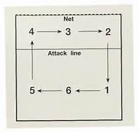
Note:
The rotation goes CLOCKWISE but the positions are COUNTERCLOCKWISE.
Server in Position #1 (back row)

The Ready Position

You should be in an athletic position with your knees and hips flexed; your feet should be about shoulder-width apart, and all your weight should be on the balls of your feet.

Setting

Setting is a necessary skill, but it’s hard to master. Usually the second contact of the possession is a set. In a set, the player uses the finger pads to launch the ball high in the air toward hitters.
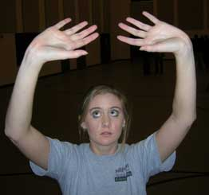
Start with your fingers spread above your head: “the triangle or diamond". The fingers should be in a diamond shape to start, and they should finish outward.

Wrists are shock-absorbers, not source of power!
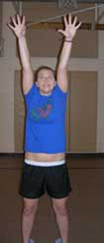
Most of the power for the set comes from the legs and the triceps. It is not all in the wrist! Elbows come out wider than the shoulders and fully extend.

Extend, extend, extend
Setters must know their hitters well—know where they like the balls placed, how high in the air, etc. Strong right-handed hitters start in the front-left corner; lefties start in the front-right. Setters also need to know where the blockers are on the other team and set up their hitters accordingly.
The Bump
Make a fist with your left hand with the thumb on top, and cover the left fist with your right hand. Your thumbs should line up side by side. Bring your arms together straight and away from the body.
Call the ball
If you're playing in the setter's position, it is your responsibility to get the second contact on the ball on every play! If you can't get it, yell "help" and one of your teammates will (hopefully) help you out!

Serving
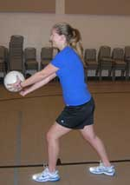
The server holds the ball in the left hand and contacts with the right to serve underhand.Each play starts off with a serve. The server steps behind the line at the very back of the court, called the end line, and has freedom to serve from wherever he or she pleases as long as the foot does not touch or cross the line. If the server’s foot crosses the end line, it is considered a foot fault, and results in a side-out—a change in possession—of the ball.

The Underhand Serve
The underhand serve is simple—the player holds the ball in the hand opposite from the hitting hand, i.e. a right-handed player would hold the ball in the left hand. Hold the ball below the waist and above the knee so that with bent knees, the server is in good position to get the ball over the net.
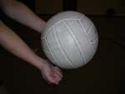
Place contact between wrist and knuckles. For a right-handed player, the ball should be held still in the left hand, and the right hand should make a fist with the thumb on top of the folded-in fingers. The right fist should make contact with the underside of the ball, and the point of contact is on the palm side of the right hand, between the folded-in fingers and the wrist. Bring the right arm back and swing through to make contact with the ball and send it over the net. The left hand should hold the ball still; do not throw the ball up or move it. The underhand serve is mainly used for lower skill levels.
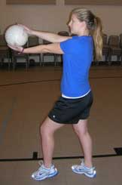

Overhand Serves: The Floater
Start with your feet. Put your left foot in front of your right, about shoulder width apart. Hold the ball at about eye-level with your left hand on the bottom and your right hand on top. The toss should only be high enough so that when you pull back your right arm, the hand contacts the ball on its downward swing. Toss the ball with your left hand; pull back your right arm as far as possible and swing—but not all the way through.
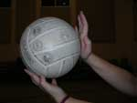
Stop forward arm swingand 'punch' the ball. Stop the motion of your right arm when your hand contacts the ball, as if you’re punching the ball to the other side of the net, and don’t snap your wrist. This serve allows the ball to float and wiggle in the air. This makes its positioning on the opposite side of the court very hard to read, and it confuses people, making it difficult for opponents to return float serves.

Topspin
The beginning steps for the topspin serve are just like the floater, but the toss for the topspin must be higher. Toss the ball high enough so that the right arm can come down on the ball in a snapping motion on the underside of the ball.
It's all in the wrist.
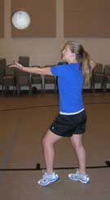
Do not stop the motion of the right arm when it contacts the ball; rather, turn your shoulder away from the ball, swing all the way through and DO snap your wrist. Snapping your wrist will deliver a hard and fast serve to your opponent. This is very similar to a tennis serve.

